Adobe Photoshop, the ubiquitous and industry standard graphics software for photographers, designers, digital artists, as well as casual enthusiasts, can be a baffling application to understand the first time you fire it up. Luckily, littered across the vast space of the web are tutorials in all shapes and sizes that will help you get up and running in no time.
In this post, I've pieced together 12 excellent Photoshop tutorials geared toward beginners. If you're a complete novice or a casual user of this software, you've stopped by the right place.
Because this is specifically for beginners — and because Photoshop's robust set of features is near-bottomless — I've skipped intermediate and advanced topics such as drawing with the Pen tool and working with 3D effects.
If you have tips for aspiring Photoshoppers, share them in the comments below.

1. Getting Started with Photoshop
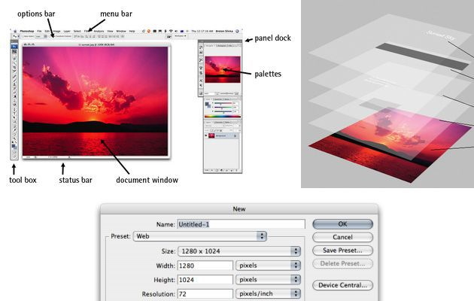

This tutorial on SitePoint, a popular site for web professionals, will guide you through the Photoshop fundamentals and the basic tools available at your disposal. It's an excellent jump-off point that will give you an understanding of what you're up against.
The tutorial starts with a bird's-eye view of Photoshop's workspace to get the reader familiarized with the lay of the land. Then it goes on to cover essential concepts such as saving files (and the various popular formats for the web), an introduction to shortcuts that all Photoshoppers should know, how to choose colors, and much more.

2. Photoshop's Toolbox
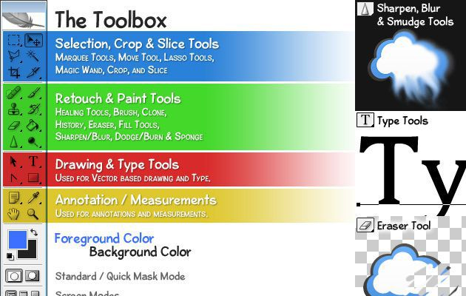

If you're just starting out with Photoshop, you will no doubt be spending plenty of your time using the Tools panel, which contains various tools for working with type, painting, drawing, moving objects, and so forth.
In this Photoshop tutorial, you will get a beginner's overview of the various tools contained within the Tools panel. From the selection tools to the retouching tools, you'll learn all about them and their uses.

3. Photoshop For Beginners: The Power of Layers
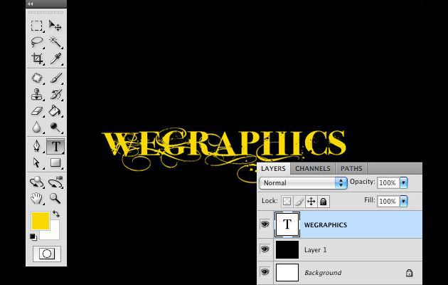

The most important concept you should understand about Photoshop is its layering system. Layers allow you to stack different objects and images to keep your work separated, ordered, and easily editable.
This guide will walk you through the utility of layers using a hands-on, step-by-step approach (so fire up Photoshop and get ready to get your hands dirty before diving in).

4. Photoshop's Filters
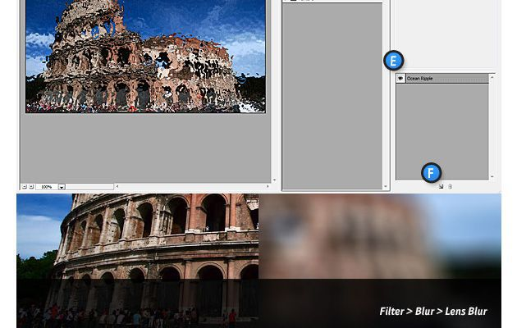

In photography, filters are camera accessories that you place on your lens to capture photos that will have fascinating effects. This concept is digitally incorporated into Photoshop and is a convenient way of editing your images quickly. Filters can be functional (such as the Sharpen filters to help you correct blurry photos) or stylistic (such as the Texture filters that give your images unique texture effects).
By reading through this tutorial, you will uncover the power of filters in Photoshop.

5. Layer Styles in Photoshop
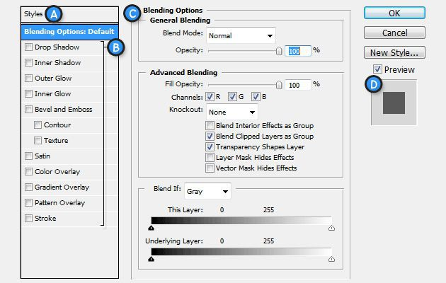

Layer styles are one or more effects that alter a layer. For example, if you wanted to make a layer semitransparent or if you wanted to give your text one of those slick "Web 2.0" gradient effects, you can do so by applying and adjusting layer styles.
Adding layer styles, using layer style presets that come with Photoshop, what the various layer effects do, and more are covered in this tutorial.

6. Photoshop 101 – Adjustment Layers
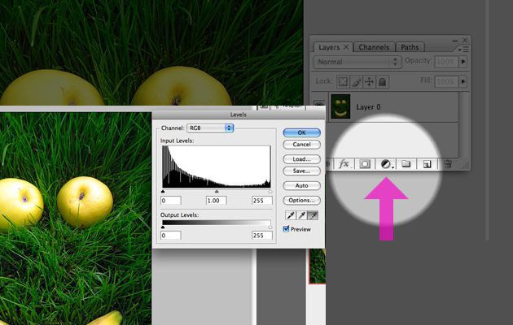

Adjustment layers are Photoshop layers that affect all other layers beneath them (unless you use an adjustment layer as a clipping mask — but that's an advanced topic for another day). It's typically used to enhance a graphic, such as if you want to adjust the colors of an image (which you can do with the Color Balance adjustment layer).
This crash course in adjustment layers shows you what you can do with them in Photoshop.

7. Retouch and Healing Tools
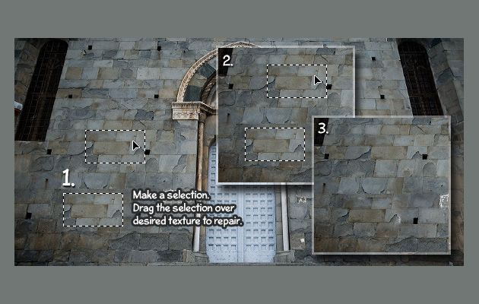

For most casual Photoshop users, the most enticing and important utility is the software's ability to correct, digitally enhance, and fix photos.
This Photoshop tutorial covers the various tools and commands that you can use to retouch and enhance your image, including a run-down of the Patch tool, sharpening tools, and more.

8. A Comprehensive Introduction to the Type Tool
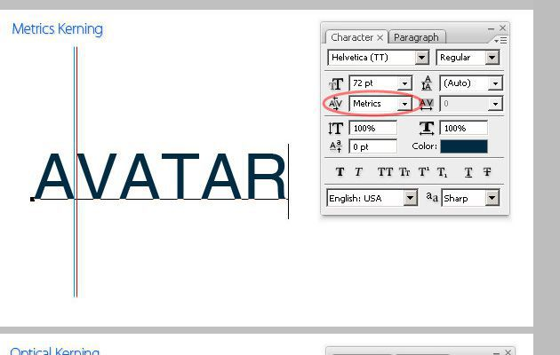

Whether you want to add a text caption on a photograph, lay out a brochure's copy, or create your typographical poster masterpiece, the tool that will help you get the work accomplished is the humble, but powerful, Type tool.
Creating text layers, resizing and modifying text, and adjusting text characteristics, such as tracking and line-height, are a few of the topics covered in this tutorial.

9. Photoshop 101: How To Use The Free Transform Tool
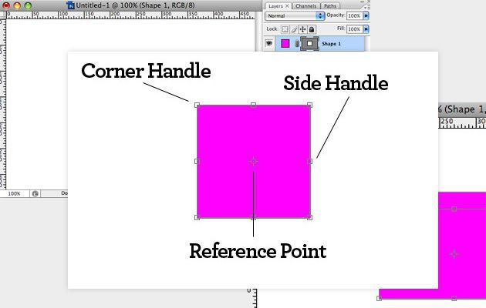

The Free Transform command is going to be your go-to tool for resizing, rotating, and modifying your graphics. This Photoshop tutorial will show you just how handy Free Transform is in your image editing workflow.

10. Master Photoshops Selection Tools in Under 30 Minutes
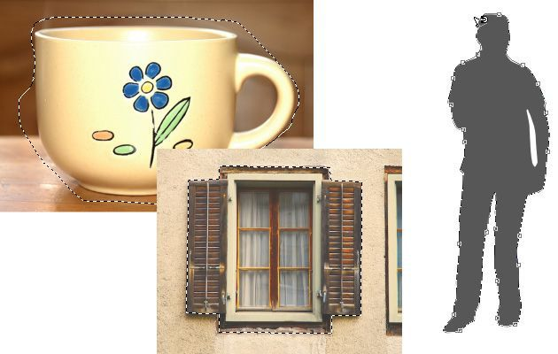

Maybe you want to remove the background from a photo, or select just a certain object in an image and use it in another Photoshop document. Whatever the case, selecting things inside your canvas is a task you should expect to do plenty of times in your 'shopping career.
Set aside 30 minutes, follow this Photoshop tutorial, and you'll know all there is to know about the assorted tools and techniques for selecting areas in your work.

11. Installing And Managing Brushes And Other Presets
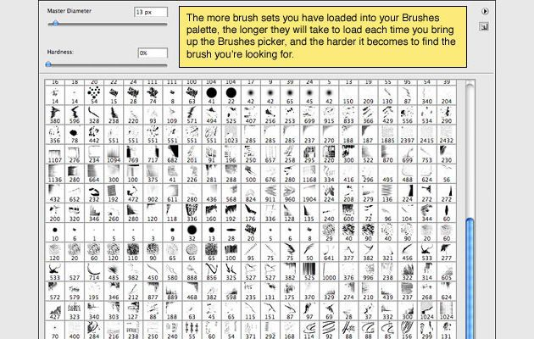

If you'd like to speed up your workflow and extend Photoshop, it's best to understand how to manage presets. This tutorial specifically covers installing and managing Photoshop brushes, but will also get you started into exploring various other presets such as patterns, custom shapes, and so forth.

12. Photoshop Actions
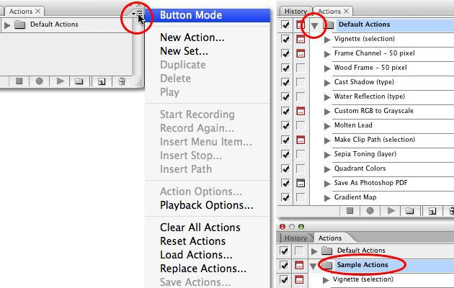

Do you find yourself repeating certain tasks in Photoshop over and over again? Maybe you're constantly resizing your images manually to a certain width and then saving them as a JPEG for use on your blog. Or maybe you've unearthed the perfect combination and sequence of filters and layer styles, and would like a way to automatically apply it to a batch of images. Check out Photoshop actions, a feature that enables you to record and save a sequence of actions.
In this 6-part tutorial, you will learn about the built-in Photoshop actions as well as how to record and save an action.
These 12 tutorials will have you on your way to Photoshop mastery. If you've had success with other tutorials not on this list, let us know about them in the comments below.

